**EAST NORWICH MEDICAL PARTNERSHIP**

**QUARTERLY NEWSLETTER**

**MARCH – JUNE 2025**

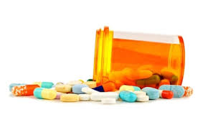

**A Message from the Practice Manager**

Hello, my name is Rachel, and I am the Practice Manager at East Norwich Medical Practice. I’ve been in this role for 7 months but have been in GP Practice for 17 years, it has been an exciting and rewarding experience. I’m dedicated to ensuring we provide the highest quality of service to all our patients.

I’m pleased to inform you that we have recently completed a major refurbishment at the practice. I’d like to take this opportunity to sincerely thank you for your understanding and patience during the renovation period. We are truly grateful for your support.

As part of the refurbishment, we’ve added 7 new clinical rooms and a larger, more comfortable waiting area upstairs. These improvements will help us continue to provide excellent care and improve your experience at the practice.

Thank you again for being a part of our community, and I look forward to continuing to work together to provide the best possible care.

Warm regards,  
Rachel

**What the practice did in the month of February 2025**

Appointment booked -3044

Physio Appointments - 123

Total call made to the surgery – 14915

DNA – DID NOT ATTEND APPOINTMENTS -105 (17.75hours)

**PLT**

**(Protected Learning Time)**

Please note that both surgeries will be closed from 13.00pm – 18.00pm for staff training on the dates below

**Wednesday 23rd April 2025**

**Thursday 24th July 2025**

**Thursday 23rd October 2025**

If you need medical assistance during this time please attend the walk in centre if you are able or call 111 , if it’s an emergency please attend A&E or call 999.

**Prescription Requests - Important Information**

Please note that we do not accept prescription requests over the phone. Our prescription line is reserved for medication queries and hospital letters only.

To order your medication, you have several options:

1. **NHS App** – You can easily order prescriptions through the NHS app.
2. **Online Access** – Sign up for online access via our practice website.
3. **Paper Requests** – Drop off your paper prescription request in the box at the front entrance of the surgery.
4. **Postal Requests** – Alternatively, you can send your request through the post.

**Thank you for your cooperation!**

**Opening times**

**The phone lines at both of our sites are open from 08.00am to 6pm Monday to Friday**

**The surgery is closed at weekends and all bank Holidays**

**SARA ADAMS -** Stepping into General Practice in the late 1990’s from an Accident and Emergency background was initially daunting but I soon learned to enjoy caring for people presenting with a wide variety of Primary Care conditions rather than just accidents and emergencies.

**Introducing Our Advanced Nurse Practitioner**



Since leaving A&E, I have worked in five General Practice settings in Cambridgeshire and Norfolk, becoming experienced in the many different conditions which patients can present with in a Primary Care setting. Working alongside GP mentors enabled me to gain experience and knowledge.

In the past I have been the lead Nurse Practitioner for Type 2 diabetes and asthma management. I have a vast working knowledge of managing patients with acute respiratory illnesses, urine infections, vaginal issues, acute abdominal pain and change in bowel habit, acute injuries, acute and chronic skin conditions, contraception counselling and period problems, managing raised blood pressure and cholesterol as well as all manner of other problems.  I have a special interest in menopause management.

Although working independently as a Nurse Practitioner, there is always a GP to discuss cases of uncertainty which further enhances learning and makes for safe and competent practice.

I am pleased to be working for ENMP and have been made very welcome by the staff and patients since starting here in July 2024.

**DOCTORS**

**Dr Hayder Abdelmutti – Male**

Special Interests – Gynaecology and Obstetrics, Mental Health , Asthma & COPD

**Dr Andrew Few – Male**

Special Interests – Psychiatry, Accident & Emergency medicine, Minor Surgery & Joint Injections.

**Dr Gil Rattner – Male**

Special Interests – Diabetes & ENT

**Dr Sabine Scherzinger – Female**

Special interests- Diabetes, Family planning, Care of the elderly & Hypertension

**Dr Bede Okoye – Male -** Salaried GP

**Dr Ebenezer Olulade – Male -** Salaried GP

**Dr Dmitry Pshezhetskiy – Male -** GP Locum

**Dr Jamiu Yussuf – Male -** GP Locum

**OTHER CLINICIANS**

**Physician Associate – Maryam**

**Pharmacists x 3**

**Physio x2**

**Mental health Nurse, Mind worker and Social Prescriber**

**NURSING TEAM**

**Sara Adams – Female - ANP**

**(Advanced Nurse Practitioner)**

**3 x Nurses**

**1 x Asthma/COPD Nurse**

**4 x Phlebotomists**

**3 x Healthcare assistant**

**SECRETARIES**

2 x Secretaries

**RECEPTION TEAM**

4x Shift lead & 5x receptionists

**PRESCRIPTION TEAM**

4 x Part time staff members

**ADMINISTRATION** (workflow team)

2 x Fulltime staff members

2 x Part time staff members

**PRACTICE MANAGEMENT TEAM**

Rachel Sparks **-Practice Manager**

Lisa Trower **– Business Manager**

Corrinne Davage **– IT Manager**

Amy Bennett **– Operations Manager**

Carol Postle **– Compliance Manager**

**Did you know that pharmacies are able to help with a range of conditions and even prescribe treatments? Before contacting your GP surgery, consider whether your condition could be treated at your local pharmacy.**

**Pharmacists are trained to provide expert advice and treatment for many common health issues, which can free up appointments for those who need to see a GP. By choosing the pharmacy for certain treatments, you’ll ensure you're seen by the right clinician and help us manage appointments more efficiently.**

**Stop and think before you reach out to your GP — your pharmacy may be able to help!**

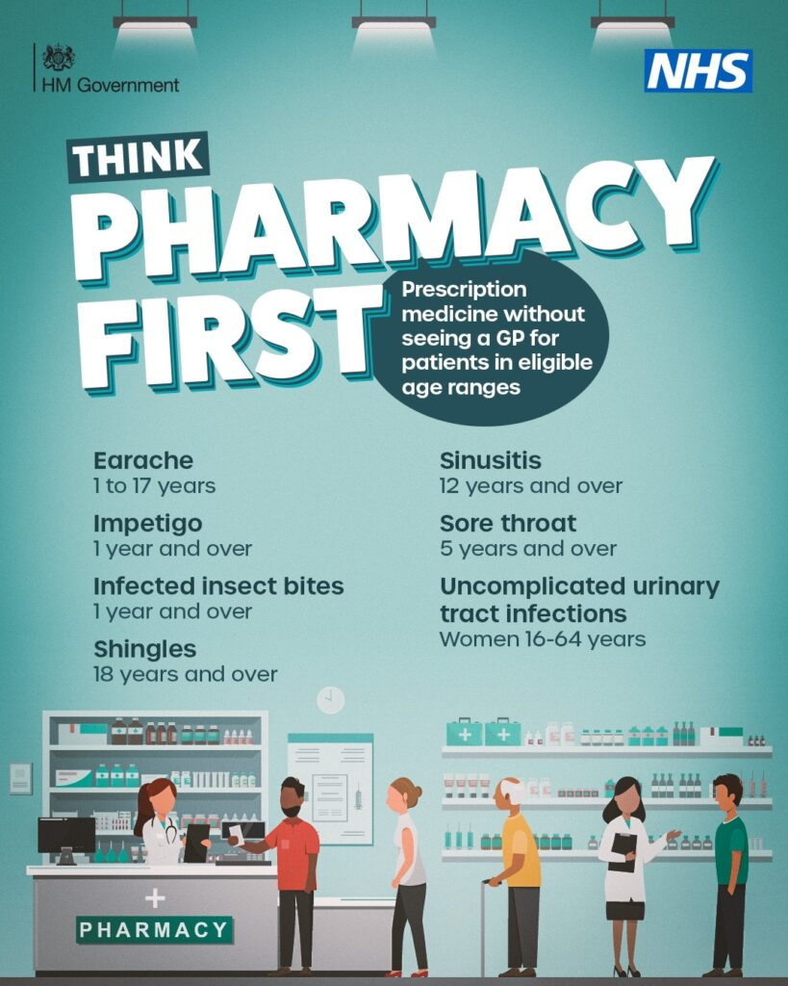

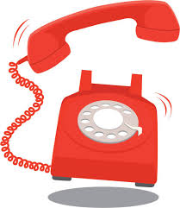

The practice appointment system is a combination of telephone and face to face appointments.

We do advise for non -urgent enquiries/routine appointments such as Blood test or HCA Appointments to call later in the day. If you require a same day appointment, please call from 8:00 onwards.  Once the practice has reached capacity, we will then advise the patient to contact one of the other providers such as Walk in Centre, 111 or their local pharmacy who have been set up to support general practice.

For emergencies, possible stroke, heart attacks, broken limbs etc. We advise patient to either contact 999 or attend the Emergency Department.

The clinicians at the above services have access to the patients Summary Care record in the patients GP record. This gives the clinicians the patient’s basic health information such as allergies and current medications.

Non-urgent enquiries can also be made via the practice website [www.eastnorwichmedicalpartnership.co.uk](http://www.eastnorwichmedicalpartnership.co.uk) Select “ask the practice a question” on the home page.

**Telephone and Booking system -** The telephone system is computerised with the lines opening at 8am. Patients are then entered automatically into the call queuing system; the call queue holds calls to maximum number of 30. Once this number has been reached a message should state the call queue is full, please try again later.

If there are more than 8 callers in the queue, you will be offered the option of a callback. Should you select this option your position in the queue is saved. Once you reach call position 1 you will receive your call back.

Please beware, depending upon the number of callers ahead of you and your position in the queue your callback could take anywhere from 1 minute to 1 hour to come through.

If you receive your callback, but the phone goes through to your voicemail, this still counts as your callback. The practice will leave a message, but you will need to call again which may involve rejoining the queue. If you receive a callback, but the phone connects and there is no voicemail, your call will be returned to the queue. The practice will try to call you twice more, and if you do not answer on the third attempt, you place in the queue is lost which will require you to call the practice to restart the process.

If you have requested a callback, please be patient, if you call again when already in the queue for a callback and request a callback you will not get a call any quicker, but instead will be set to have two callbacks, which only blocks the line for other patients.