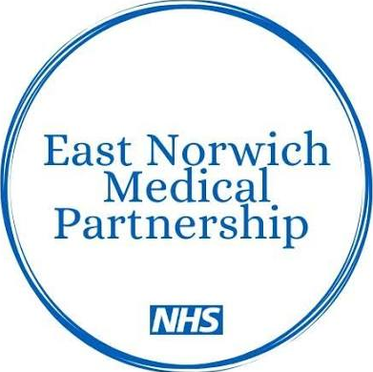
EAST NORWICH MEDICAL PARTNERSHIP
PATIENT QUARTERLY NEWSLETTER
JULY-SEPTEMBER 2026


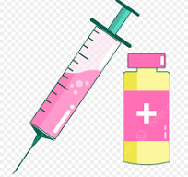
Flu Campaign:
Throughout October, we will be running our dedicated Saturday Flu Clinics at our Sprowston site, as well as several Weekday Flu Clinics at both Sprowston and Thorpe.
Welcome to our latest newsletter:
In this edition, you will learn about the newest members of our clinical team, find out more about our autumn flu vaccination clinics and understand how Pharmacy First can help treat you for some of the most common conditions, without the need for a GP consult.

PARTNERS:
DR HAYDER ABDELMUTTI (Male):
Gynaecology, Obstetrics, Mental Health, Asthma and COPD.
DR ANDREW FEW (Male):
Psychiatry, A&E Medicine and Minor Surgery.
DR GIL RATTNER (Male):
Diabetes and ENT.
DR SABINE SCHERZINGER (Female):
Diabetes, Family Planning, Eldercare and Hypertension.
SALARY GENERAL PRACTITIONERS:
DR RAFIUL ANWAR (Male)
DR LUCY BOYLES (Female):
HRT and Menopause.
DR IBITHAL MOHAMED (Female):
Coils.
DR EBENEZER OLULADE (Male):
Palliative care and caring for patients with complex needs.
PHYSICIAN’S ASSISTANTS:
MISS ANISHA AL-FIRDOUS
MRS MARYAM BAWALA
Meet our New Team Members:
We are delighted to introduce to you three new staff members joining our clinical team.
We wish them the best of luck and we’re sure you will give them a very warm welcome.
Dr Lucy Boyles: One of our newest General Practitioner’s (GP) who will be working five sessions per week. She will be working closely with our existing clinical team to provide dedicated patient care to every patient across the practice.
Dr Rafiul Anwar: I will be working six sessions per week. I have been living in Norfolk for the past 3 years and working across a few local surgeries, so it is a real pleasure to join East Norwich and serve the community here.
A bit about my background: I completed my medical training at Imperial College London, graduating in 2013, and went on to finish my GP training in the West Midlands in 2019. I really enjoy the variety that general practice brings every day.
When I’m not in the clinic, most of my time is spent keeping up with my three energetic young kids, who keep my wife and me on our toes! To relax, I love unwinding with good music, reading, picking up my guitar or heading off on a family adventure whenever we get the chance to travel.
Nurse Dorothy: Our newest member of our Nursing Team who will be working three and a half days per week. The nursing team support patients with a wide variety of care needs, such as: Preventative healthcare, vaccinations, routine health checks and the management of long-term health disorders.

Patient Feedback:
In July 2026, Healthwatch Norfolk visited our Sprowston site to speak with our patients about their experiences with health and social care services. 13 patients provided feedback, with our average star rating as 3.5 out of 5 stars.
Positives:
Enough parking spaces available for patients, including two accessible spaces close to the entrance.
Automatic doors at the entrance.
Toilets and waiting rooms were clean and tidy.
Staff attitudes are positive.
Nursing teams are excellent.
Physiotherapists are very good.
Negatives:
Difficult to book/get an appointment.
Not easy having to phone in at 8am.
Certain doctors are dismissive and arrogant.
We are actively implementing our action plan, based off the feedback from the patients, to improve the quality of care experienced at East Norwich Medical Partnership.


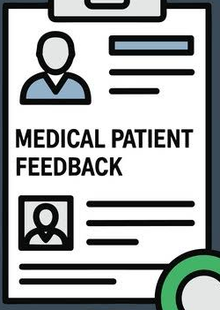



Pharmacy First Service:
The Pharmacy First Service is a free NHS Service in England that lets patients get expert health advice, and prescription treatment for seven common conditions, directly from a local high street pharmacy, without needing a GP appointment!
You can walk into a participating pharmacy, contact them online or by phone, or be referred by your GP surgery or NHS 111. You speak with a pharmacist in a private consultation room. The pharmacist asks about your symptoms and checks your health needs. If needed, the pharmacist supplies prescription-only medicines (like antibiotics or antivirals) or advises on over-the-counter products. Standard NHS prescription charges apply if you normally pay for prescriptions. The pharmacy sends a note to your GP surgery on the same day or the next working day, so your medical record stays up to date.
Please see below the common conditions Pharmacy First treat and for which ages:
Earache- for people aged 1-17.
Impetigo- for people aged 1 and over.
Infected insect bites- for people aged 1 and over.
Shingles- for adults aged 18 and over.
Sinusitis- for people aged 12 and over.
Sore throat- for people aged 5 and over.
UTI’s- for women aged 16-64.

Patient Participation Groups- We Need Your Support:
Our Patient Participation Group is an official group of patients and GP Practice staff that work together to improve the care and the health services East Norwich Medical Partnership provides.
If you are interested, please either contact the surgery on 01603 778277 or come into the surgery to speak to one of our receptionists- please provide your details and your permission for your details to be passed to the leader of our Patient Participation Groups, who will contact you directly with further information.



